**UNIX LAB**

**ASSIGNMENT 2**

Name: Sreekesh Iyer Class/Roll No. D10A/24

**Aim:** To understand basic UNIX commands in Linux shell.

**echo:** Used to display a line of text/String that is passed as an argument.   
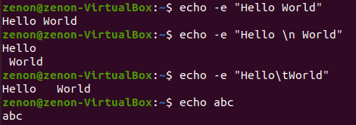  
  
**clear:** Used to clear the terminal screen  
  
  
**exit:** Used to exit the currently running shell.   
  
**date:** Used to display system date and time. Can also be used to set system date and time.



**time:** Used to execute a command and prints a summary of real-time user CPU time and system CPU time spent by executing a command when it terminates.   
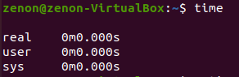

**uptime:** Shows how long the system has been up and running.   


**cal:** Used to see the calendar of a specific month or a whole year. By default, it shows the current month’s calendar as output (system).

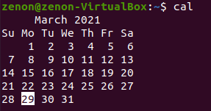

**cat:** Reads data from a file and gives the content inside as output. Can also be used for creating, viewing and concatenating files.

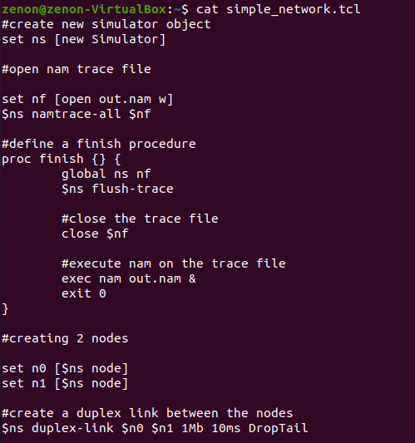

**tty:** Displays the information related to the terminal. It basically prints the file name of the terminal connected to standard input.



**man:** Used to display the user manual of any command which is run on the terminal.

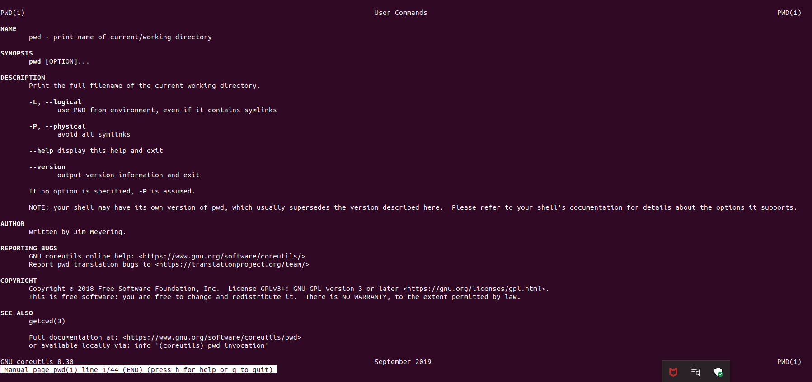

**which:** used to locate the executable file associated with the given command by searching it in the path environment variable.



**history:** Used to view the previously executed commands.   
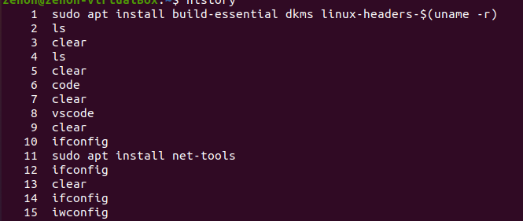

**id:** Used to find out user and group names and numeric IDs(UID or group ID) of the current user or any other user in the server.   


**pwd:** Prints the path of the current working directory starting from the root.



**whoami:** Prints the username of the current system user.



**ping:** Used to check connectivity between the host and a server/host.   
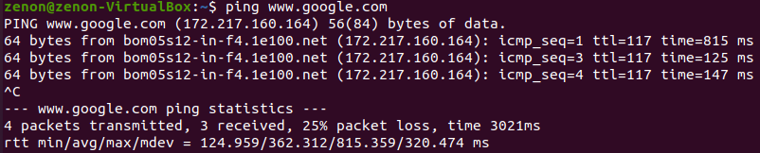

**ifconfig:** Used to configure the kernel-resident network interfaces.   
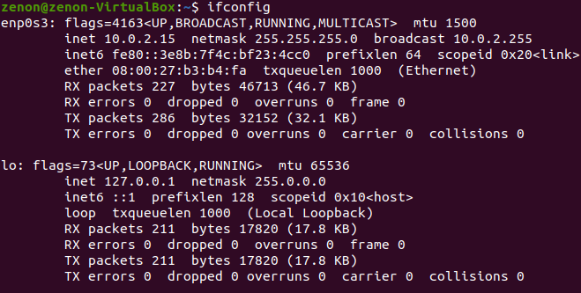  
  
**pr:** To prepare a file for printing by adding suitable footers, headers and formatted text. The header part shows the date and time of the last modification of the file with the file name and page number.

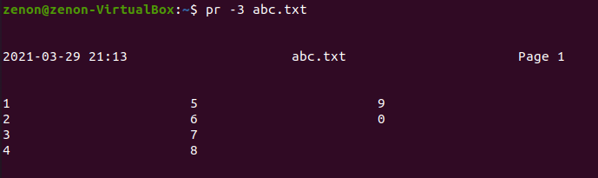

**lpr:** lpr submits files for printing. Files named on the command line are sent to the named printer. If no files are listed, lpr reads the print file from standard input.

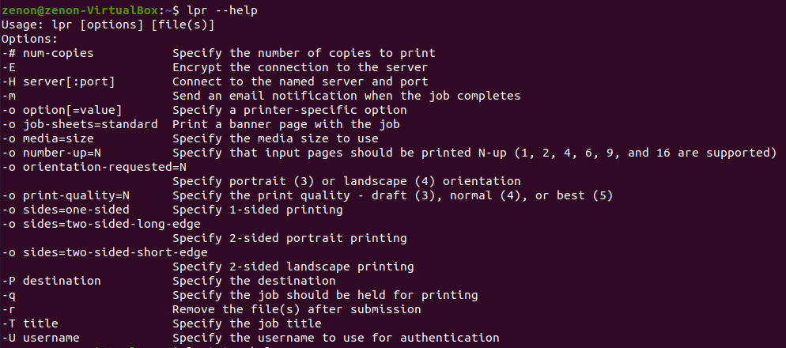

**lpstat:** lpstat displays the status information of the current classes, jobs and printers.   
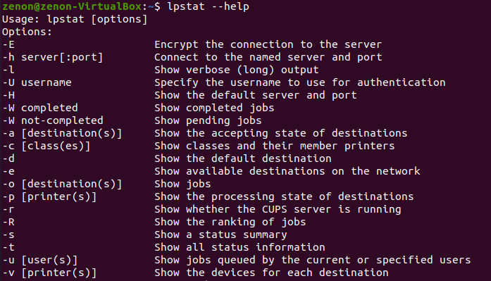

**lprm:** lprm cancels print jobs that have been queued for printing. If no arguments are supplied, the current job on the default destination is cancelled.

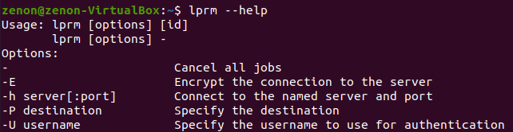

**cancel:** cancel cancels the existing print jobs. The -a option removes all jobs from the specified destination.

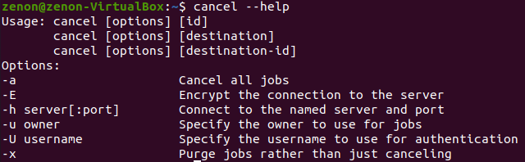

**mail:** Linux mail command is used to send mails from the command line.   
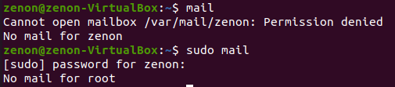  
  
File System Management  
  
**ls:** It shows the full list or content of your directory



**cd:** Known as change directory command. Used to change the current working directory.  


**pwd:** Prints the path of the working directory starting from root.   


**cat:** Reads data from the file and gives its content as output. It helps us to create, view and concatenate files.  
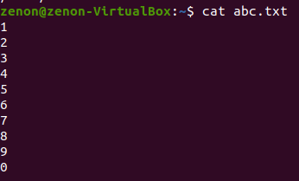

**mkdir:** Creating Directories. Also for Multiple Directories.   


**rmdir:** Remove empty Directories from the file system in Linux.   
  
  
**rm:** Used to remove objects such as files, directories, symbolic links and so on from the file system like UNIX.  
**cp:** Used to copy files or group of files or a directory  
  
  
**mv:** Used to move one or more files or directories from one place to another in a file system like UNIX.   
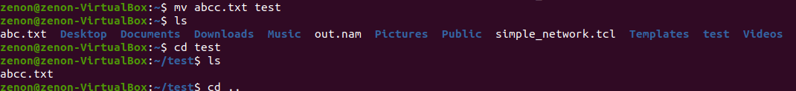

**chmod:** Used to change the access mode of a file  
  
  
**wc:** Used to find out no. of lines, word count, byte and character count in the files specified in the file arguments.  
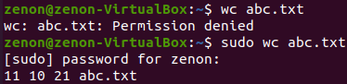

**grep:** The grep filter searches for a file for a particular pattern of characters, displays all lines that contain that pattern. GREP stands for Globally search for Regular Expression and Print.   
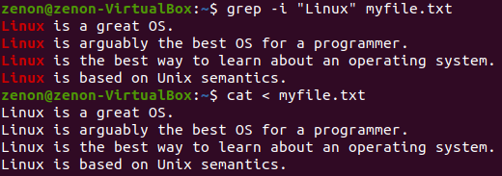  
  
**tr:** The tr command in UNIX is a command line utility for translating or deleting characters. It supports a range of transformations including uppercase to lowercase, squeezing repeating characters, deleting specific characters and basic find and replace. It can be used with UNIX pipes to support more complex translation. Tr stands for translate.   
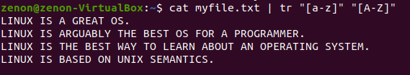

**sort:** Command used to sort a file, arranging records in a particular order. By default, the sort command sorts file assuming the contents are ASCII. Using options in sort command, it can also be used to sort numerically.   
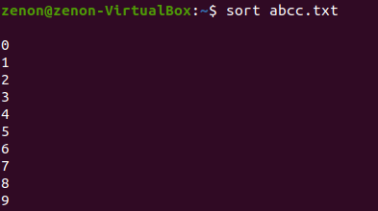

**file:** The file command is used to determine the type of a file. It may be human-readable or MIME type. This command tests each argument in an attempt to categorize it.   


**find:** Used for walking a file hierarchy. Can be used to find files and directories and perform subsequent operations on them.   


**vim:** On Unix-like operating systems, vim, which stands for “Vi Improved” is a text editor, can be used for editing any kind of text and is especially suited for editing computer programs. Most often, vim is started to edit a single file using command: vim file  


**Piping:**

A pipe is a form of redirection (transfer of standard output to some other destination) that is used in Linux and other Unix-like operating systems to send the output of one command/program/process to another command/program/process for further processing. The Unix/Linux systems allow stdout of a command to be connected to stdin of another command. You can make it do so by using the pipe character ‘|’.

Pipe is used to combine two or more commands, and in this, the output of one command acts as input to another command, and this command’s output may act as input to the next command and so on. It can also be visualized as a temporary connection between two or more commands/ programs/ processes. The command line programs that do the further processing are referred to as filters.

Pipes are unidirectional i.e data flows from left to right through the pipeline.

**User Management**

**who:** Used to get information about currently logged in user on to system  


**whoami:** Displays the username of the current user when this command is invoked.   
  
  
**su:** Short for substitute or switch user, it allows you to run commands with other user’s privileges, by the default root user. It’s the simplest way to switch to the administrative account in the current login session.   
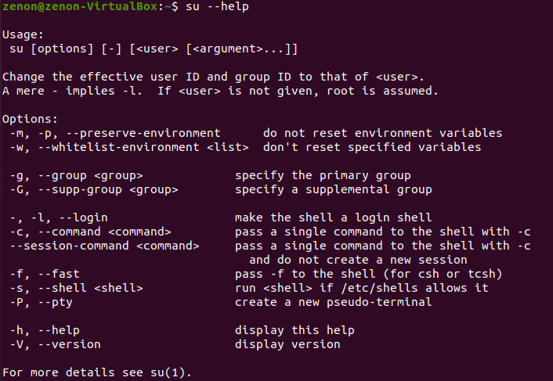

**login:** Used when signing onto a system.

**logout:** Signing out of a system.

**exit:** To exit the currently running shell.

**passwd:** To change user account passwords. The root user receives the privilege to change passwords for any user on the system.

**usermod:** Used to change the properties of a user in Linux through the command line.  
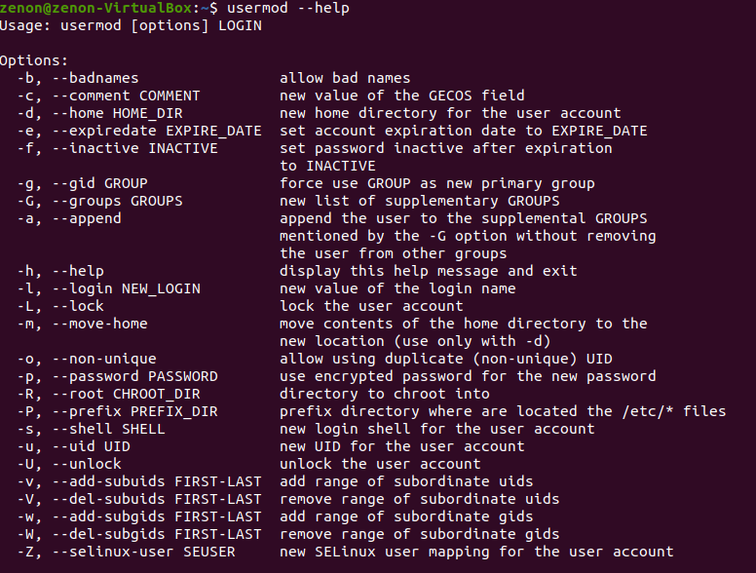

**userdel:** userdel command in Linux system is used to delete a user account and related files. This command basically modifies the system account files, deleting all the entries which refer to the username LOGIN. It is a low-level utility for removing the users.  
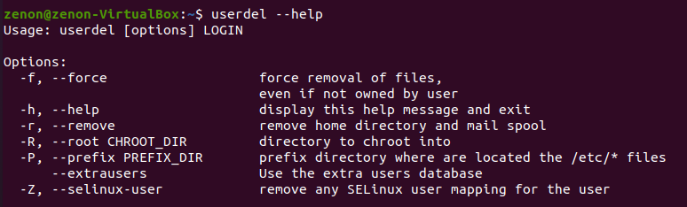

**groupadd:** In Linux, there can be many users of a single system, (normal users can take uid from 1000 to 60000, and one root user (uid 0) and 999 system users (uid 1 to 999)). In a scenario where there are many users, there might be some privileges that some users have and some don’t, and it becomes difficult to manage all the permissions at the individual user level. So using groups, we can group together a number of users, and set privileges and permissions for the entire group. groupadd command is used to create a new user group.   
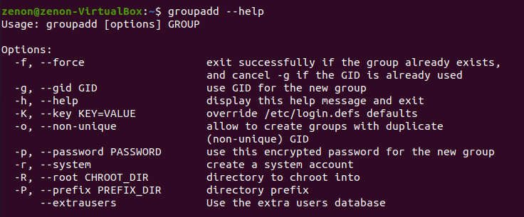

**groupmod:** groupmod command in Linux is used to modify or change the existing group on Linux systems. It can be handled by superuser or root user. Basically, it modifies a group definition on the system by modifying the right entry in the database of the group.  
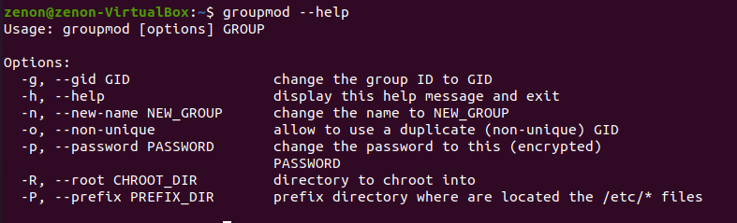

**groupdel:** groupdel command is used to delete an existing group. It will delete all entries that refer to the group, modify the system account files, and it is handled by superuser or root user.   
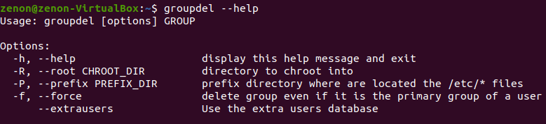

**gpasswd:** gpasswd command is used to administer the /etc/group and /etc/gshadow. As every group in Linux has administrators, members, and a password. It is an inherent security problem as more than one person is permitted to know the password. However, groups can perform cooperation between different users. This command assigns a user to a group with some security criteria. This command is called by a group administrator with a group name only which prompts for the new password of the group.  
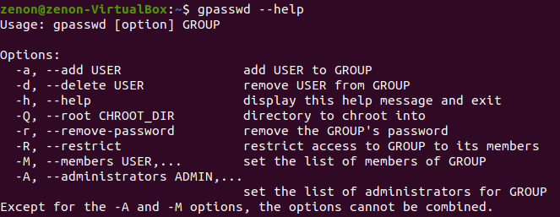

**chown:** Used to change the file Owner or group.  
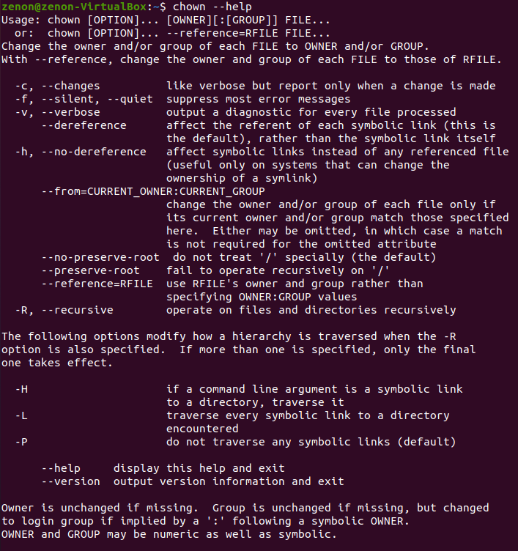

**chage:** chage command is used to view and change the user password expiry information. This command is used when the login is to be provided for a user for a limited amount of time or when it is necessary to change the login password from time to time. With the help of this command we can view the aging information of an account, date when the password was previously changed, set the password changing time, lock an account after a certain amount of time etc.  
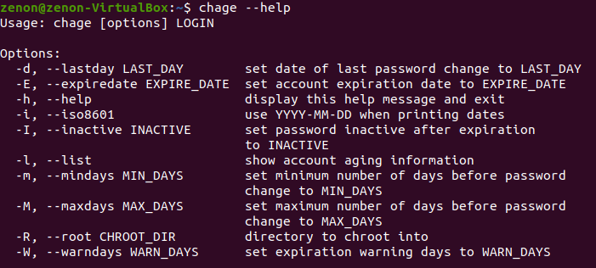

**chfn:** chfn command in Linux allows you to change a user’s name and other details easily. chfn stands for Change finger. Basically, it is used to modify your finger information on Linux systems. This information is generally stored in the file /etc/passwd that includes the user's original name, work phone number etc.  
